**Configuration Migration Tool: Working Smarter with Metadata Entities**

Download Microsoft Dynamics CRM SDK

Link to Download SDK (https://www.microsoft.com/en-in/download/details.aspx?id=40321)

Steps to Export the Data from MS CRM

Step 1: Extract SDK File Go to Tools Folder and Open Configuration Migration Folder and click DataMigrationUtility you can see the below figure.

Step 2: Select on Create Schema and click on continue button

[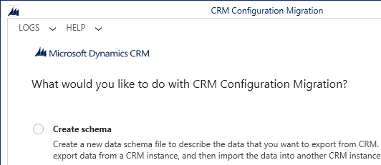](http://msdn.microsoft.com/en-us/library/dn647421.aspx)

Step 3: Fill the Login Credentials as Mentioned below in the Figure.

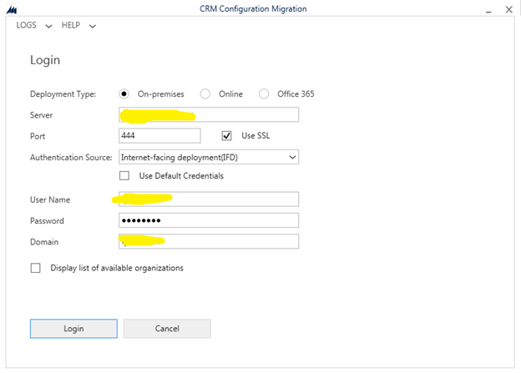

Step 4: If Select the Display List of available organization in the previous figure you will be able to see all the organization.

Select any one organization and then click on login Button

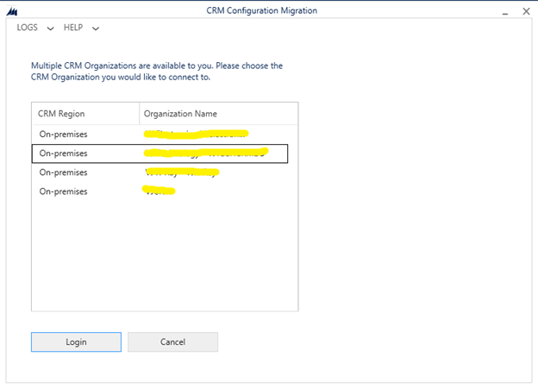

Step 5: Select the Solution you want to download.

Select the any one Entity and click and entity or Add ALL and

Click on Save and Import Button

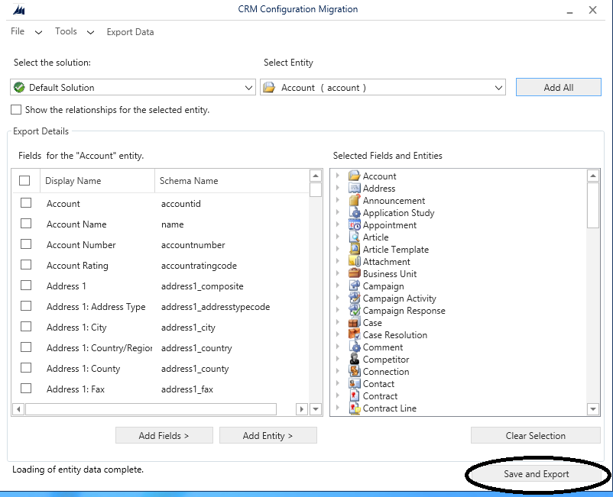

Reference to Step 5

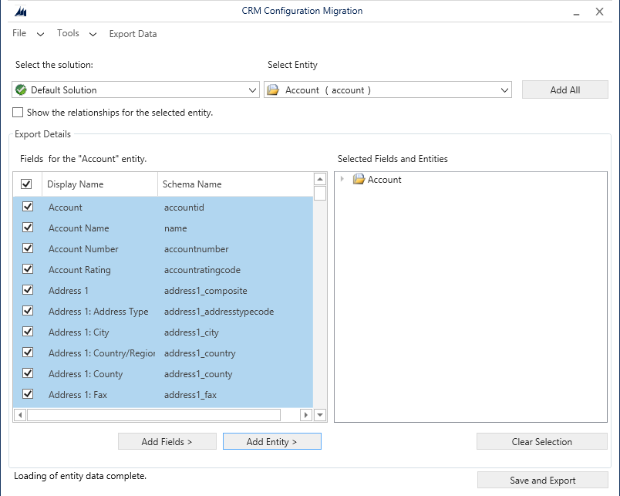

Reference to Step 5

Step 6: Give a Name for the file and Click on Save and then Click on Save and Export Button.

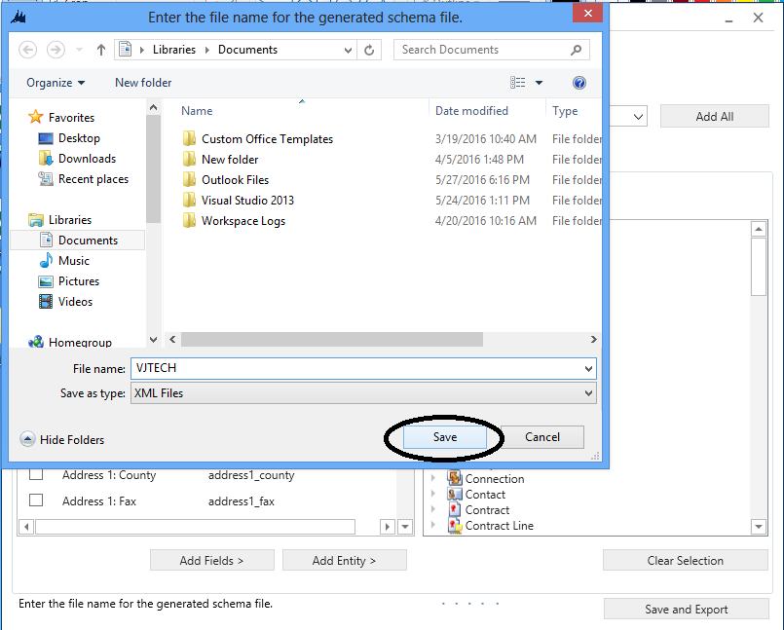

Step 7: You will see the below Alert message click on Yes

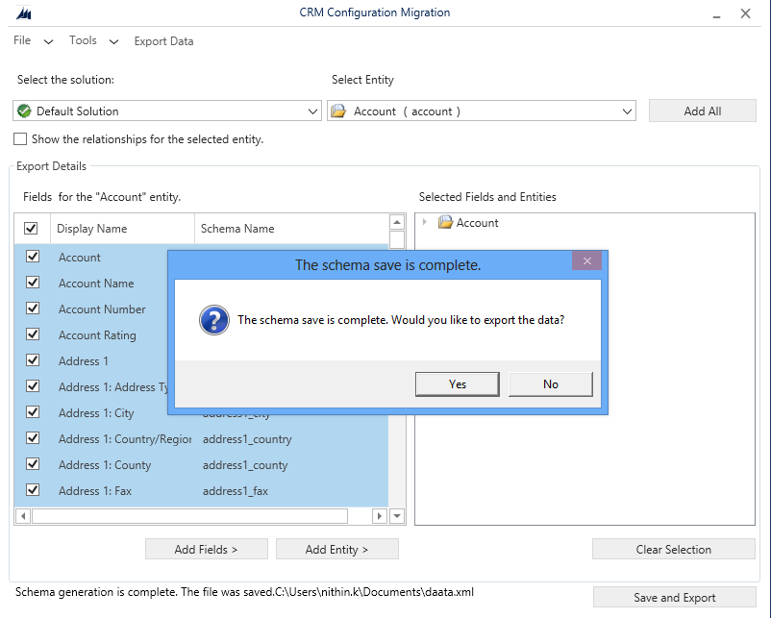

Step 8: It Will be redirected to this page and Click on Save to Data file and then give a different file name for the File save option Menu.

And Click on Export Data.

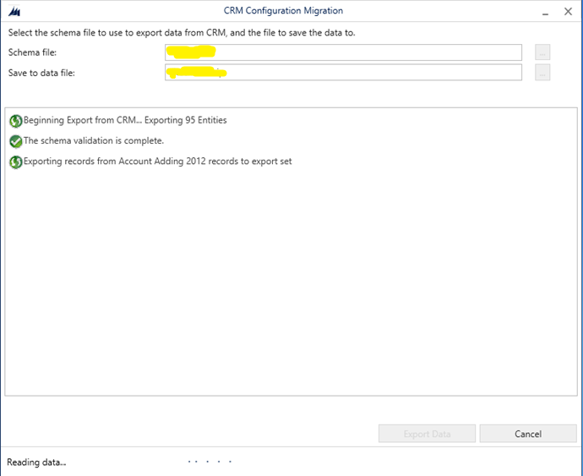

Step 9: Need to wait till the Complete Message as shown in (Step 10: Figure). (Need to wait if you have more Data)

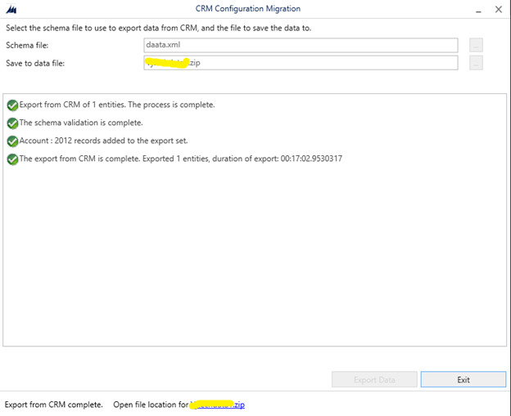

Step 10: Exporting data is completed.



Importing File to MS CRM

Step 1: Select Import Data and Click on Continue

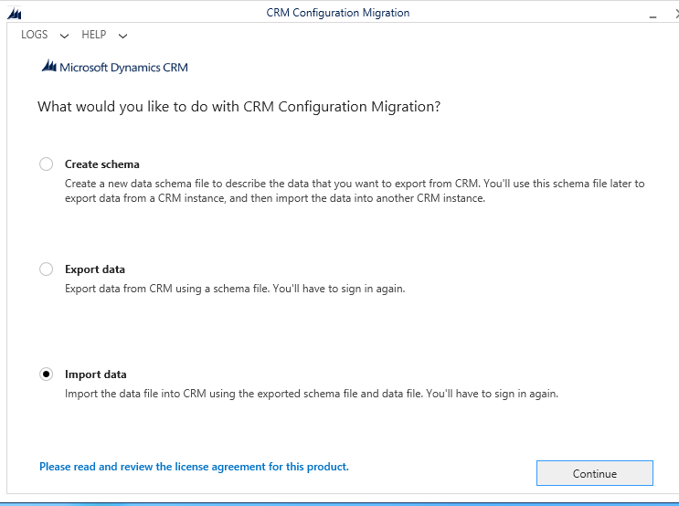

Step 2: Fill the Login Credentials as Mentioned below in the Figure.



Step 3: If Select the Display List of available organization in the previous figure you will be able to see all the organization.

Select any one organization and then click on login Button



Step 4: Select the file that need to be imported and Click on Import Data.

Wait till the Data is Imported Success fully.

